1. 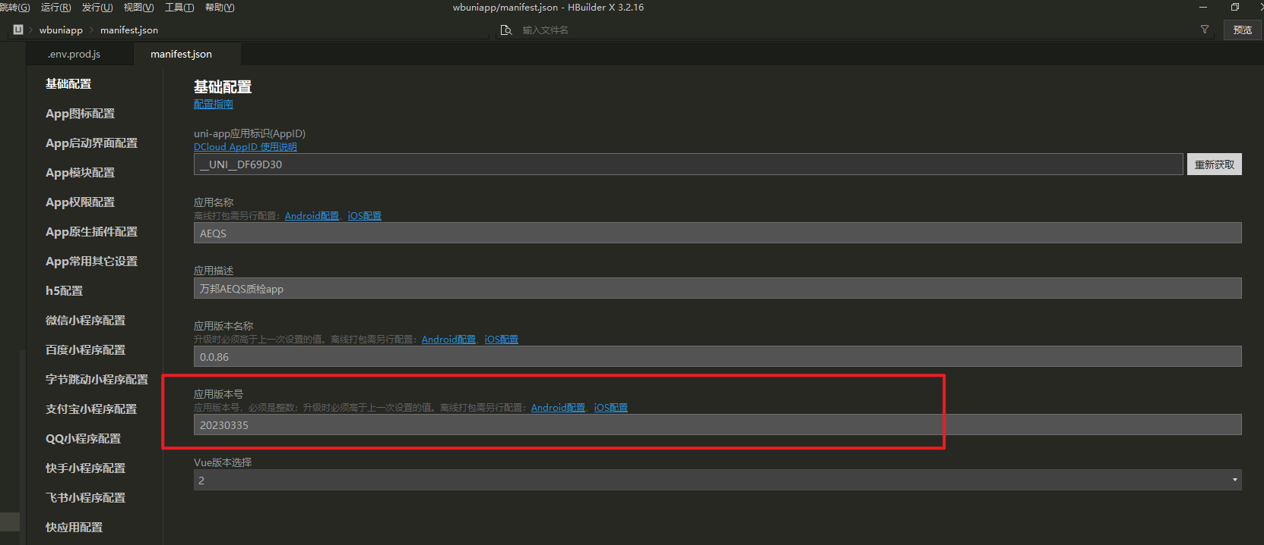
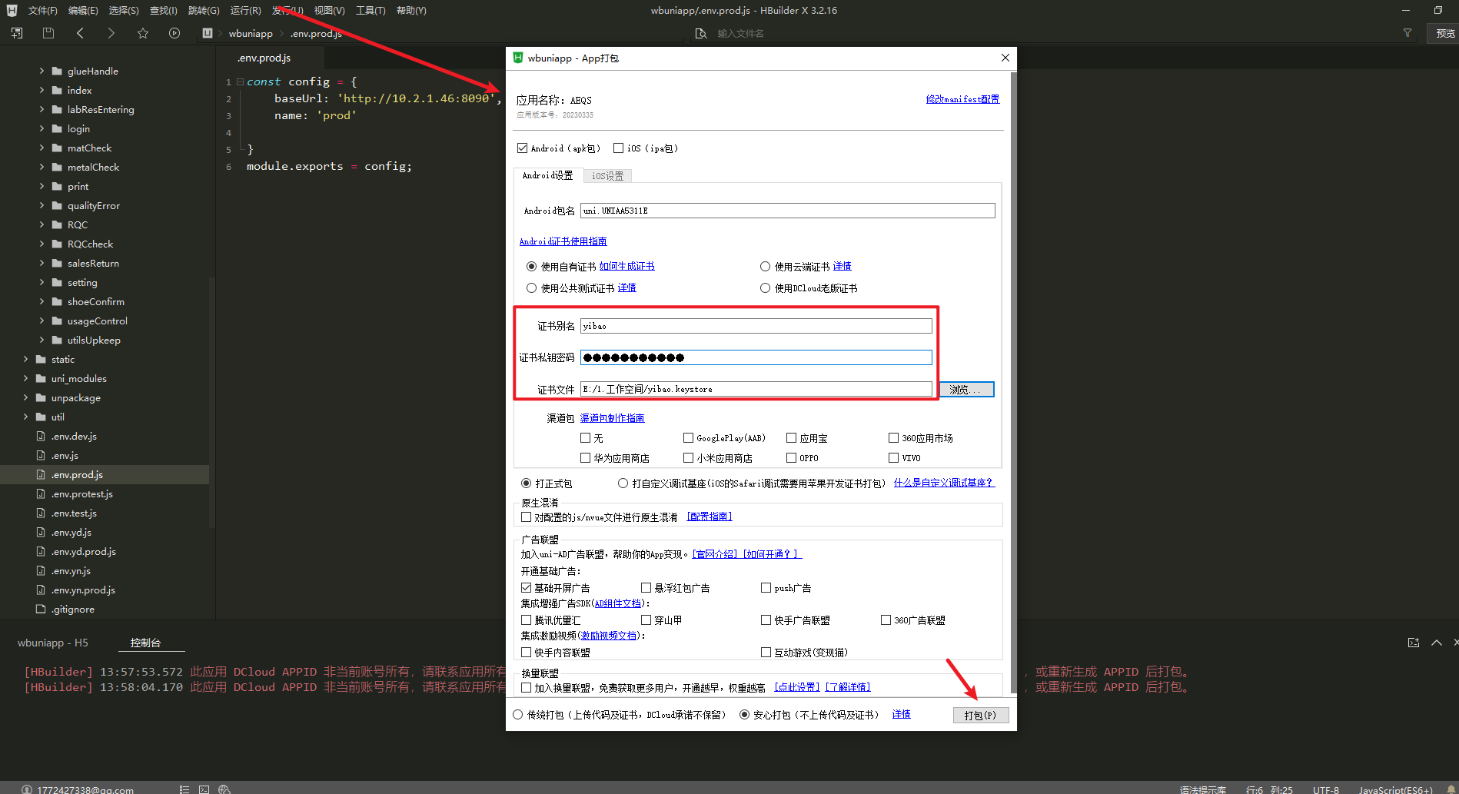

2. APP_VERSION table
App_version: Represents the app version number (it must be greater than the version number of the online APP to update)
Download_url: Represents the URL for APP download

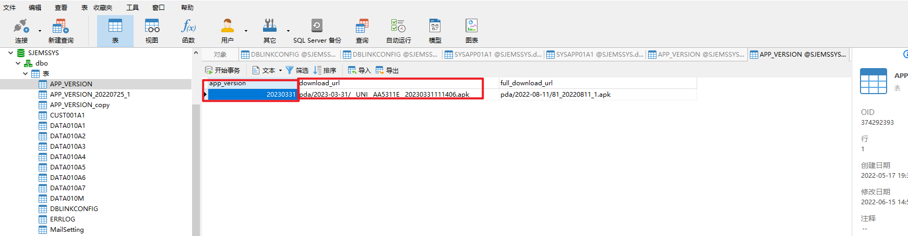

3. The newly packaged APK needs to be placed in the folder of the file upload site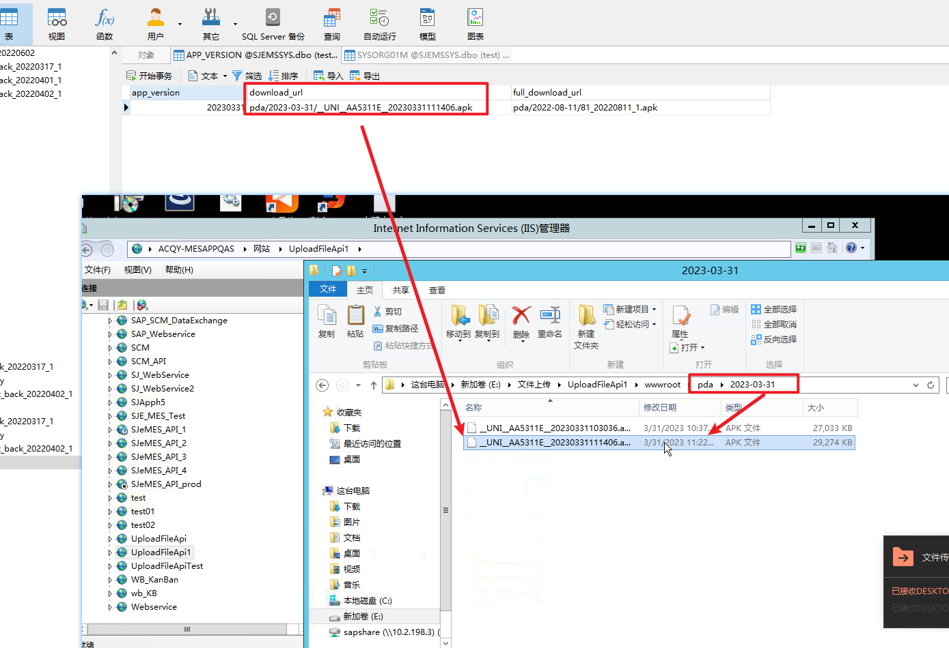
4. After performing the above steps, opening the APP will automatically prompt to update.

